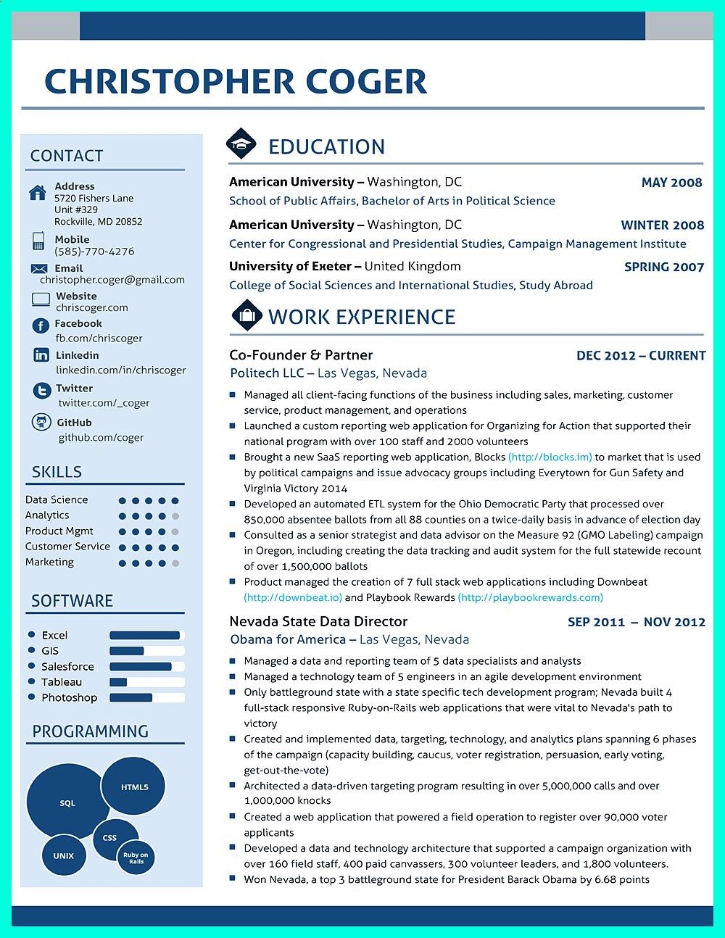
CHRISTOPHER COGER
CONTACT
Address
5720 Fishers Lane Unit #329
Rockville, MD 20852
Mobile
(585)-770-4276
Email
christopher.coger@gmail.com
EDUCATION
American University - Washington, DC
MAY 2008
School of Public Affairs, Bachelor of Arts in Political Science
American University-Washington, DC
WINTER 2008
Center for Congressional and Presidential Studies, Campaign Management Institute
University of Exeter-United Kingdom
SPRING 2007
College of Social Sciences and International Studies, Study Abroad
Website
chriscoger.com
f Facebook
WORK EXPERIENCE
fb.com/chriscoger
in Linkedin
Co-Founder & Partner
DEC 2012- CURRENT
linkedin.com/in/chriscoger
Politech LLC Las Vegas, Nevada
Twitter
twitter.com/_coger
GitHub
github.com/coger
SKILLS
Data Science
Analytics
Product Mgmt
Customer Service Marketing
SOFTWARE
Excel GIS
Salesforce
Tableau Photoshop
PROGRAMMING
SQL
HTMLS
98
UNIX
CSS
Ruby on
Rails
Managed all client-facing functions of the business including sales, marketing, customer service, product management, and operations
Launched a custom reporting web application for Organizing for Action that supported their national program with over 100 staff and 2000 volunteers
■Brought a new SaaS reporting web application, Blocks (http://blocks.im) to market that is used by political campaigns and issue advocacy groups including Everytown for Gun Safety and Virginia Victory 2014
■Developed an automated ETL system for the Ohio Democratic Party that processed over
850,000 absentee ballots from all 88 counties on a twice-daily basis in advance of election day Consulted as a senior strategist and data advisor on the Measure 92 (GMO Labeling) campaign in Oregon, including creating the data tracking and audit system for the full statewide recount of over 1,500,000 ballots
Product managed the creation of 7 full stack web applications including Downbeat (http://downbeat.io) and Playbook Rewards (http://playbookrewards.com)
Nevada State Data Director
Obama for America - Las Vegas, Nevada
SEP 2011
NOV 2012
■ Managed a data and reporting team of 5 data specialists and analysts ■Managed a technology team of 5 engineers in an agile development environment Only battleground state with a state specific tech development program; Nevada built 4 full-stack responsive Ruby-on-Rails web applications that were vital to Nevada's path to victory
Created and implemented data, targeting, technology, and analytics plans spanning 6 phases of the campaign (capacity building, caucus, voter registration, persuasion, early voting, get-out-the-vote)
Architected a data-driven targeting program resulting in over 5,000,000 calls and over 1,000,000 knocks
■Created a web application that powered a field operation to register over 90,000 voter applicants
■Developed a data and technology architecture that supported a campaign organization with over 160 field staff, 400 paid canvassers, 300 volunteer leaders, and 1,800 volunteers. ☐ Won Nevada, a top 3 battleground state for President Barack Obama by 6.68 points

